Frequently Asked Questions andUseful Information

for New Residents

Did You Know?

Trash day is MONDAY. Bulk pick-up is the 1st Monday each month. Recycling is every other week. Put your bin(s) out Sunday evening.

**Village ordinance says that grass over 6” tall is a violation. These and other zoning requirements can be found in the Codified Ordinance library, or if you have zoning questions, contact the Department of Development.**

You can rent the Community Center for private events! See our app for all the details.

Permits are needed for many things, including pools and

fences. Go to the

permitting portal on

our website for all the information.

Do you have pets? Want pets? Chickens? The Village has animal ordinances. There are also specific rules about 4H animals. Chapter 5 of Codified Ordinances has all the information you need.

The Village has a 1% income tax on all residents and workers in the Village, AND the school has an additional 1% school tax. You must register with our tax department, even if retired or unemployed.

If you are a landlord, or if you will be renting out your West Jefferson property in the future (including to family) you must register with the Department of Development.

Our three parks are amazing! Garrette Park is all-inclusive, with an amazing gravity rail, Westwood has basketball, pickleball and tennis courts in addition to ball fields, a beautiful playground and a walking trail, and Converse has several fields and is the largest of the parks. All parks are dog friendly, if on

Parks are open from

½ hour before sunrise

until ½ hour after sunset.

Need to get your cat spayed or neutered? The Village has a discount program for pets, strays, and feral cats. Contact Village Hall

for more information

about all of our cat spay and neuter programs.

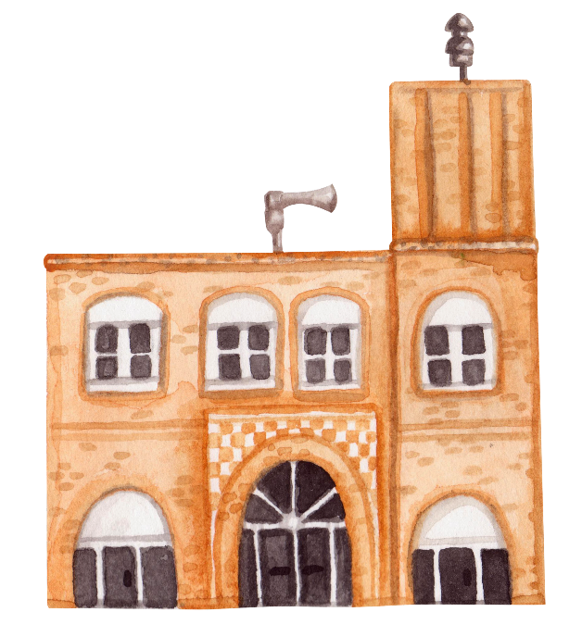

28 E. Main St.

**(614) 879-8655**

contact@westjeffersonohio.gov

a leash.



Yearly Village Main Events Calendar

All Village Hall sponsored events are FREE.

**January**

Village Hall is closed for New Year’s Day, and Martin Luther King Day

**February**

Village Hall is closed for President’s Day

Events: **Sweetheart Dance**

**March/April**

Village Hall is closed for Good Friday. Events: **Village Egg Hunt, Shop Hop**

**May**

Village Hall is closed for Memorial Day.

Pool opens Memorial weekend

Events: **Friday Night Uptown, Fishing Derby’s start, FreeCycle**

**June/ July/ August**

Events**: Friday Night Uptowns, Lunch & Learn, Fishing Derbies, Movie Nights**

Community Association’s Street Fest

**September**

Community Association’s Ox Roast

**October**

Events: **Fall Festival**

**November**

Village Hall is closed for Thanksgiving day and the following Friday

Events: **Small Business Saturday**

**December**

Community Association’s Christmas in the Park

Events: **Snowflake Dance**

Village Hall is closed Dec. 22 and 25

Want to know the official information from Village Hall?

* Download our FREE mobile app! **Village of West Jefferson Ohio,** available on Google Play or the App Store. This is used for all emergency notifications, and has tons of information.
* Follow us on Facebook! The official Village Facebook pages are:

**Village of West Jefferson, OH**

**West Jefferson Police Department**

**Village of West Jefferson Parks and Recreation**

* Check out the official Village webpage, **WestJeffersonOhio.gov.** Be patient; the site is being updated in 2024.
* Watch for news on the **Village Sign!** Located directly across the street from Village Hall.
* **Contact Mayor Ray Martin,** [rmartin@westjeffersonohio.gov](mailto:rmartin@westjeffersonohio.gov) (614) 879-7674, (614) 560-5754

Useful Contacts:

Village Hall: (614) 879-8655

WestJeffersonOhio.gov

Facebook: Village of West Jefferson, OH

Department of Development: (614) 379-5250

Access the **Permitting Portal** at WestJeffersonOhio.gov

Codified Ordinances

<https://codelibrary.amlegal.com/> Once there, click on OHIO, then select West Jefferson. The full ordinance menu will be on the left.

Village Tax Department

(614) 879-9757

Village Police Department

Non-emergency: (614) 879-7672

Facebook: West Jefferson Police Department

Jefferson Township Fire Department

Non-emergency: (614) 879-8265

West Jefferson Community Association

westjeffoxroast@gmail.com

Westjeffoxroast.org